Restaurant POS & Table Management System
Point of Sale | Order Management | Table Management | Billing | Receipts | Reports

Project Overview
A desktop based restaurant management system designed to handle daily restaurant operations from one platform. It covers order entry, dine in, takeaway, table management, billing, receipts, and sales reporting.

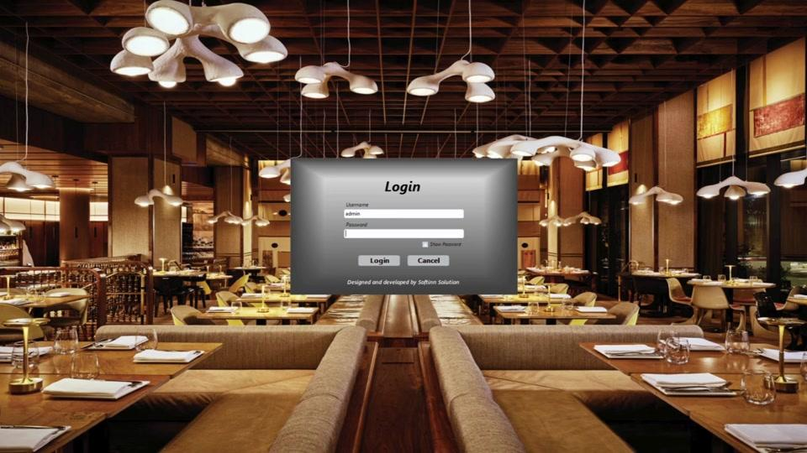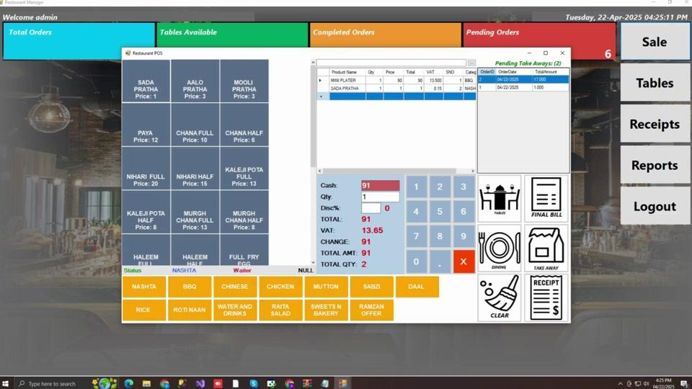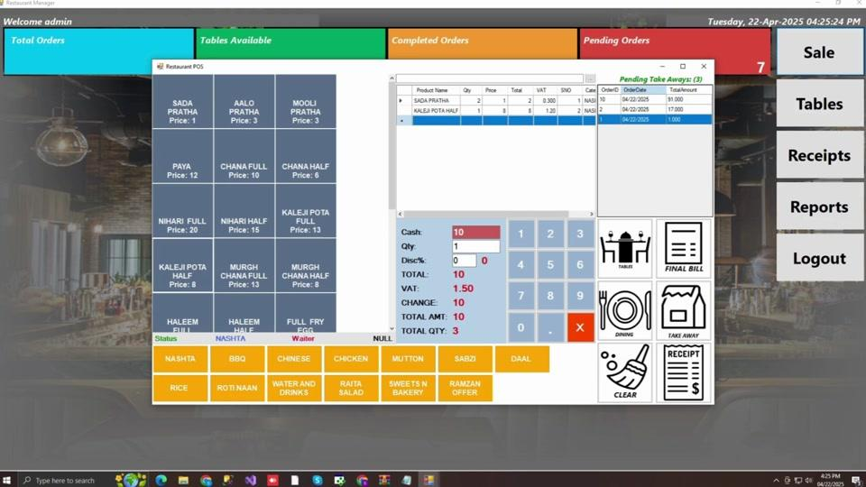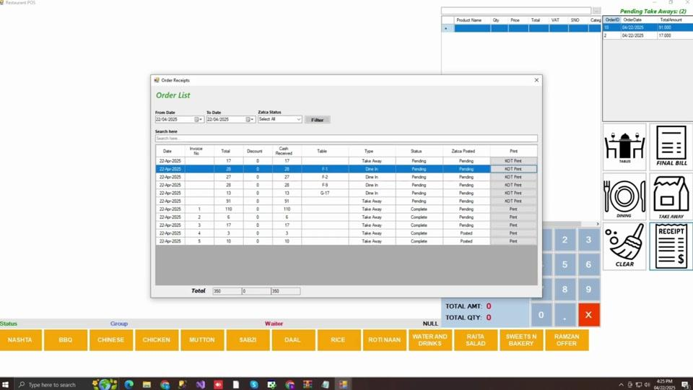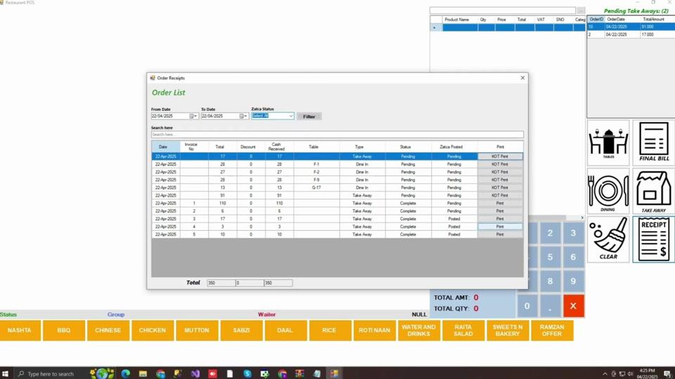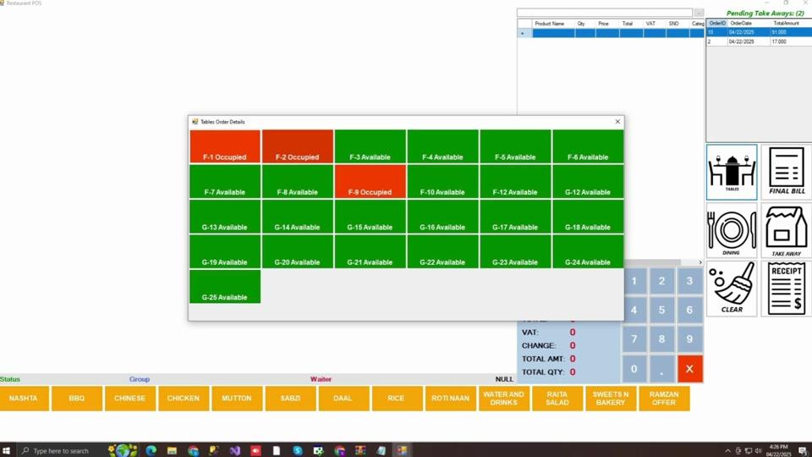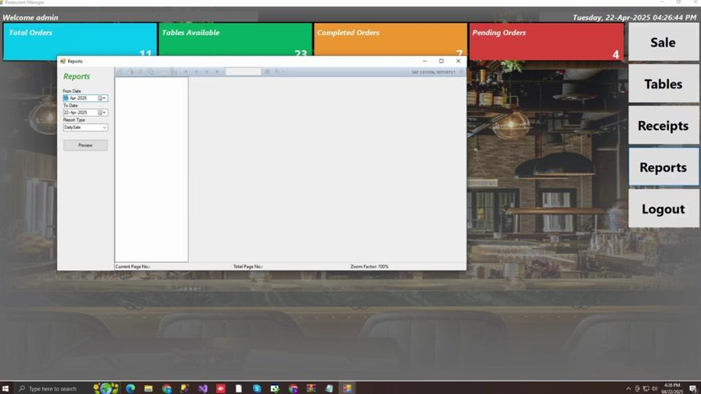

Main Modules
• Staff Login
• Restaurant Dashboard
• POS / Sales
• Menu & Categories
• Table Management
• Dine In Orders
• Takeaway Orders
• Receipt Management
• Sales Reports
• Logout

POS & Order Management
Staff can quickly create orders by selecting products from categorized menus.
• Product and category selection
• Quantity and price management
• Discounts
• VAT calculation
• Cash received and change calculation
• Total amount and quantity
• Final bill and receipt
• Clear and transaction controls

Table Management
The system provides a visual table layout showing which tables are available or occupied.
Order Flow:
Select Products → Choose Dining → Select Table → Process Order → Final Bill → Receipt

Takeaway Management
Takeaway orders are handled separately through a Pending Take Aways section, showing order ID, date, and total amount so staff can easily track outstanding orders.

Receipt Management
The receipt module allows staff to:
• Search orders
• Filter by date
• Filter by status
• View invoice numbers
• Check totals and discounts
• Review cash received
• Check table and order type
• Print receipts and KOT

Reporting
The system includes a reporting section where users can select a date range and generate reports such as Daily Sale through an integrated report preview.

User Experience
The POS is designed for fast restaurant operations with:
• Large product buttons
• Category based menu navigation
• On screen numeric keypad
• Quick Dine In and Takeaway actions
• Clear payment summary
• Color coded table status
• Quick access to Sales, Tables, Receipts and Reports

Result
The system brings restaurant sales, table management, takeaway orders, billing, receipts, and reporting into one application, giving staff a faster way to process orders while giving management better visibility into daily restaurant activity.

